**Day 4 Lab Experiment**

**1.Write a program to find the perfect number.**

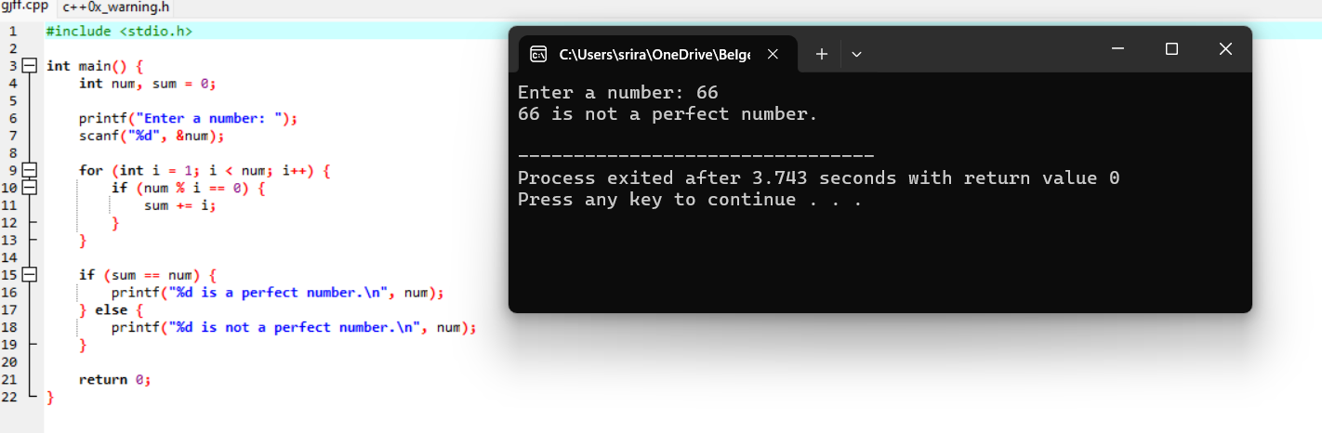

**2.Write a program to perform travelling salesman problem using dynamic programming**

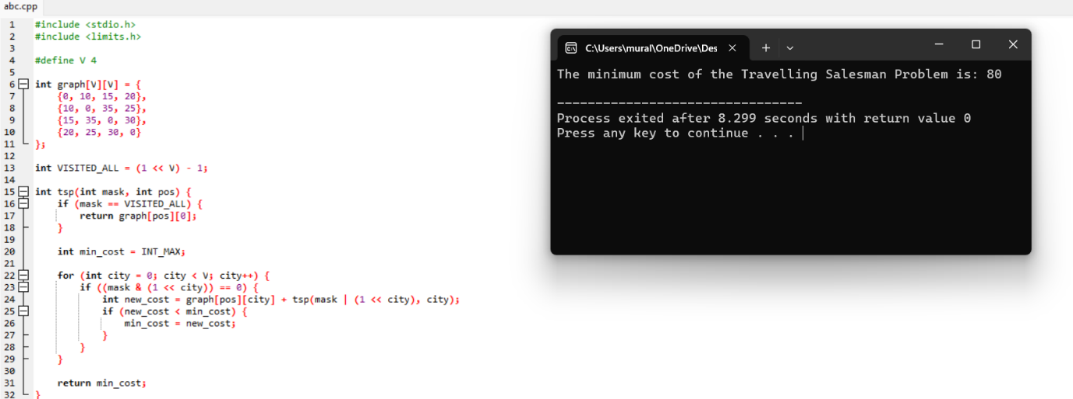

**3.Write a program for the given pattern**

**If n=4**

**1**

**1 2**

**1 2 3**

**1 2 3 4**

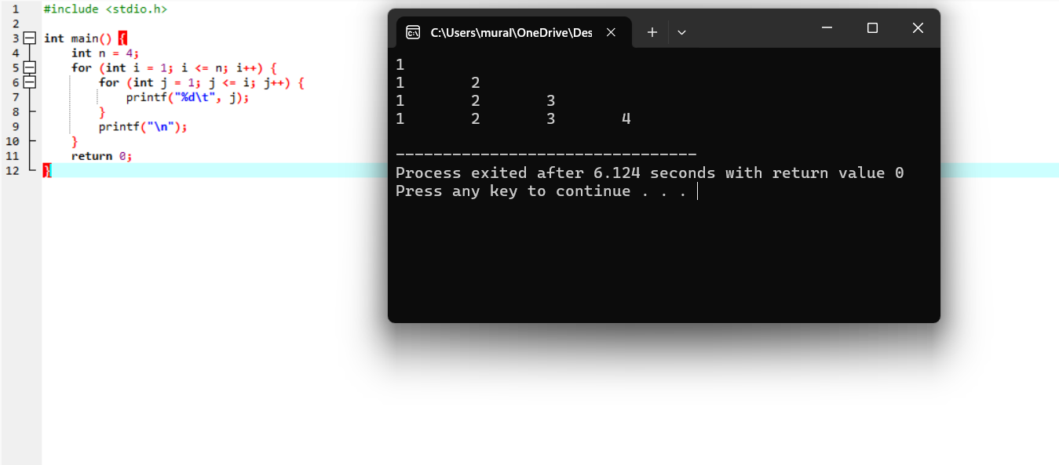

**4.Write a program for pascal triangle.**

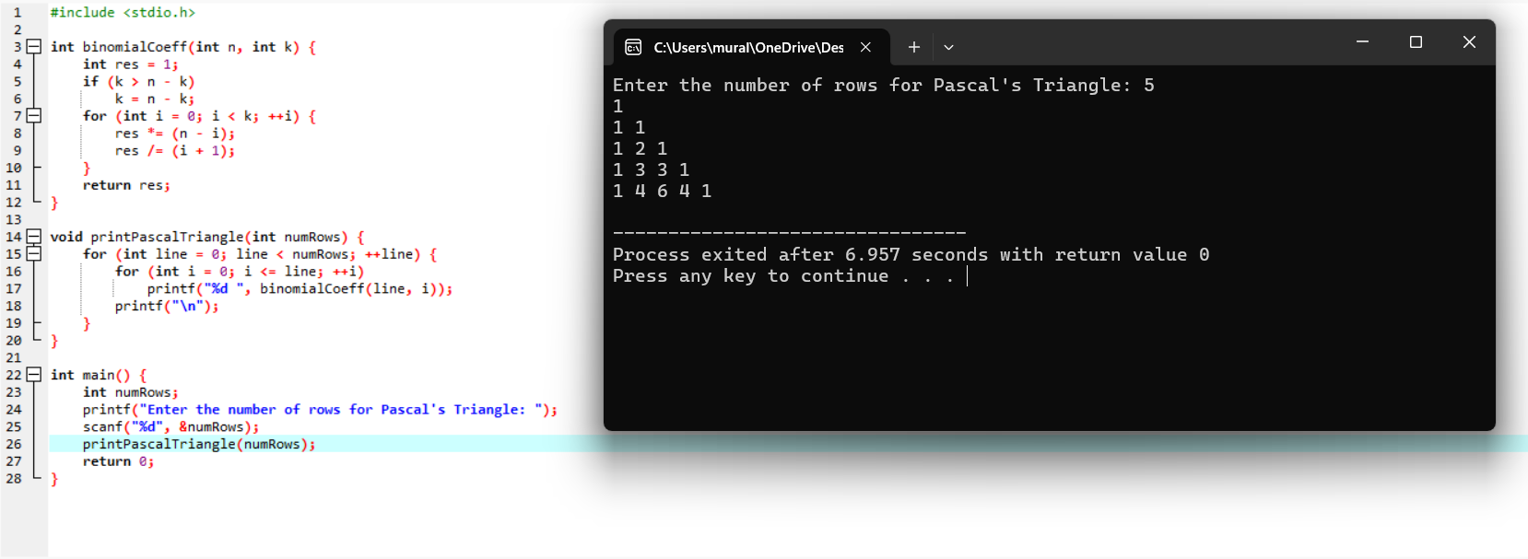

**5.Write a program to find the sum of digits.**

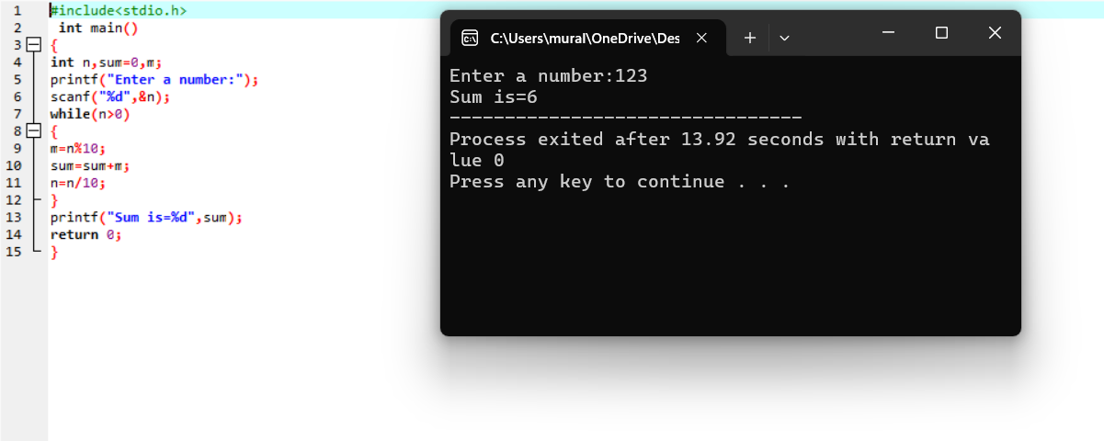

**6.Write a program to print a minimum and maximum value sequency for all the numbers in a list.**

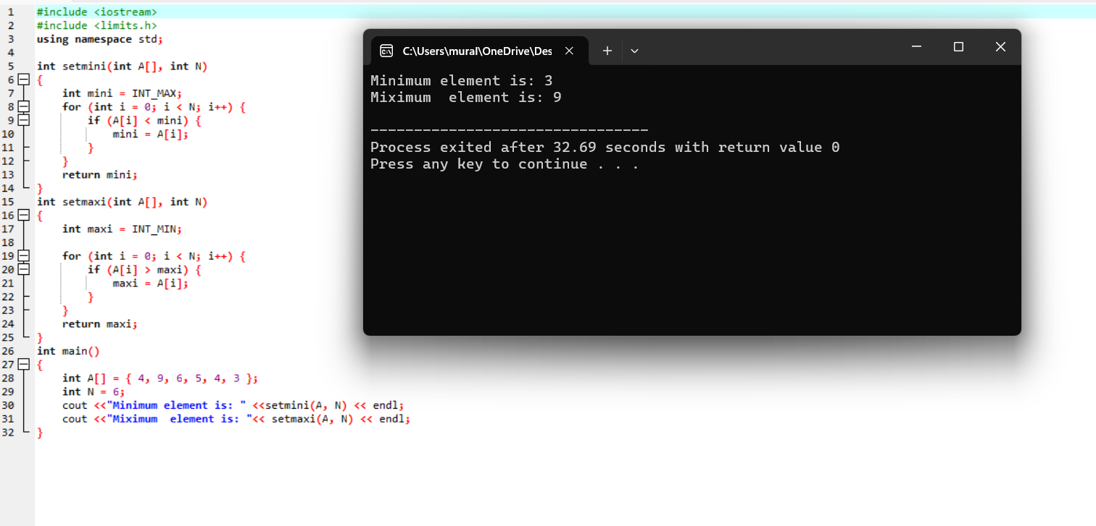

**7. Write a program to inset a number in a list.**

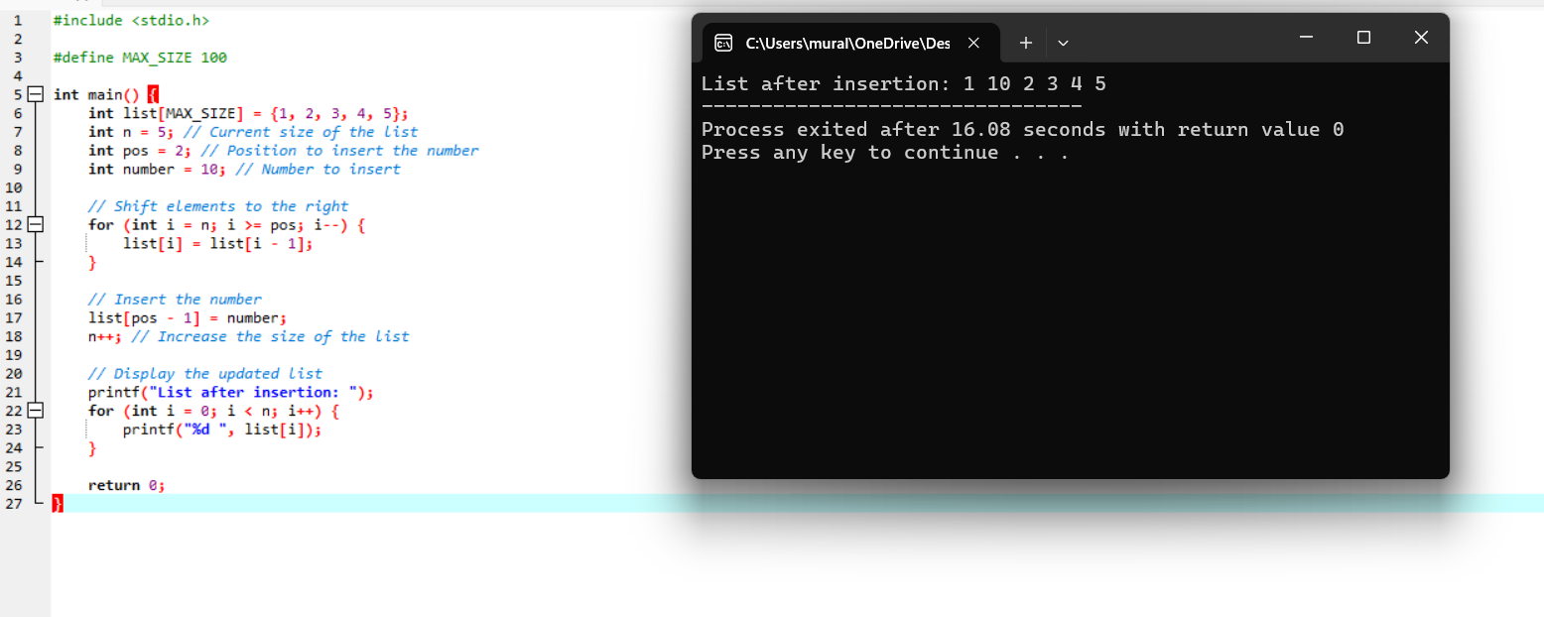

**8. Write a program to generate the list of all factor for n value.**

